
Year 10 -Pathway 2

Mini Test 5.2 -Semester 2

Statistics

Resources allowed: Calculator and 1 x A4 page one side

Name: ______________________ Class: ______ Time: 40 minutes Total Marks: ____/29

Show working and answers on this sheet. Show working in sufficient detail to support your answers. Incorrect answers without supporting reasoning may be allocated zero marks.

Question 1 (4 Marks)

Complete the calculations for the following measures of central tendency and measures of spread for the data set below:
7, 10, 11, 14, 17, 23
Median:

Q1:
Q3:
Interquartile Range:

Question 2 (3 Marks)

Read the box-and-whisker plot below and complete the questions:

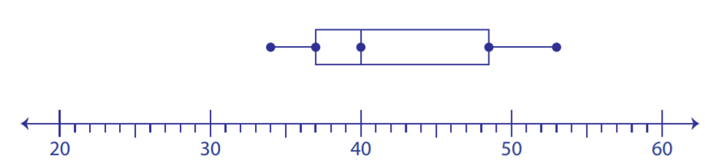

- Write the median from the above plot.

- What is the minimum number in this plot?

- Write the third quartile from the given plot?

Question 3 (3, 2- 5 Marks)

The boxplot shows the distribution of test scores in a class (Class A) of 20 students.

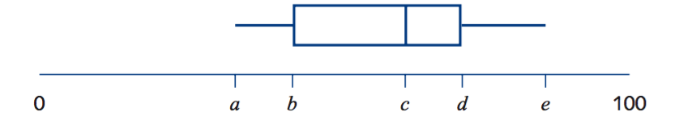
The lowest score in the class was 38, the range of the scores was 50 and the median was 61.

- Write down the values of a = c =
e =

- When all the test scores were added up the total was 1240. What was the mean of the test scores?

Question 4 (5, 5 -10 Marks)

The number of late passes issued daily by a school over a four week period were as follows:

4, 4, 4, 5, 5, 6, 6, 6, 6, 7, 7, 7, 7, 8, 8, 8, 9, 9, 10, 14

- Determine the five number summary for this data.

- Use the five number summary to construct a box plot on the scale below that reflects your response in (b).

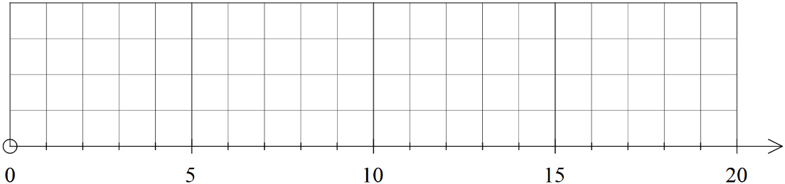

Question 5 (2, 2, 3 – 7 Marks)

For the following histograms, list as many characteristics that describe each histogram (consider symmetric, skewed to left, skewed to right, unimodal, bimodal, multimodal, outliers).

 | 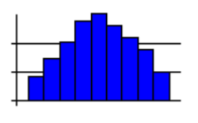 | b) | 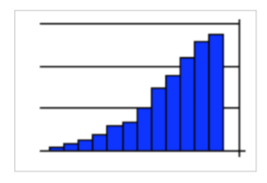

˜̴ End of Test ˜̴

